**TASK 4 – Kubernet Using Shell Script**

**Step 1: MiniKube**

Start the minikube using minikube start command

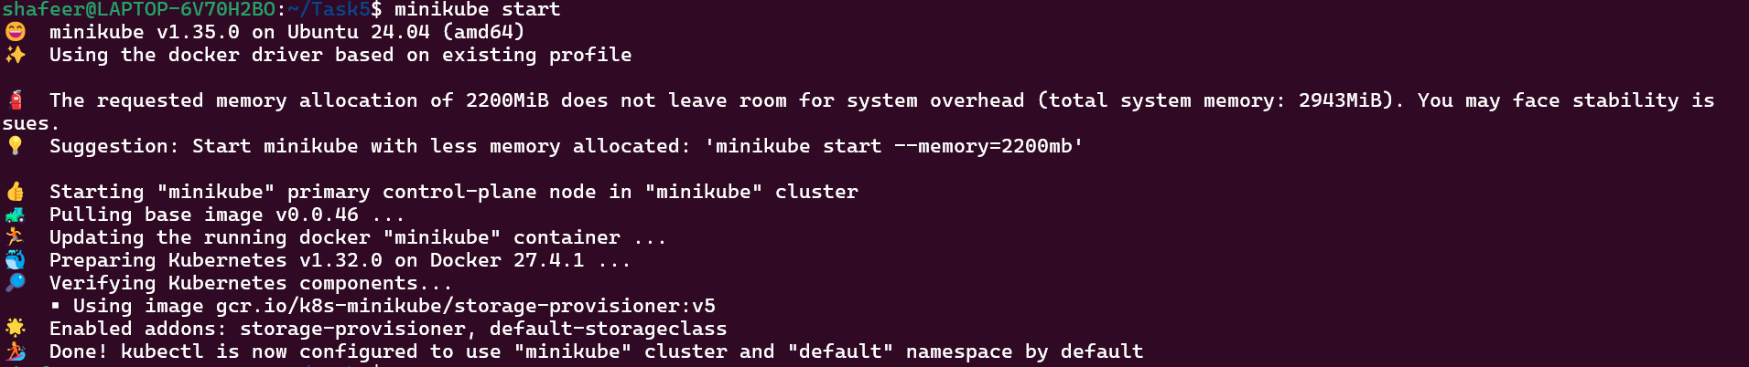

**Step 2: Folder Creation**

Create a folder named Task4



**Step 3: New Yaml File**

Create a new vim file named Task4.yaml



**Step 4: Yaml file**

Enter the yaml file code using the insert

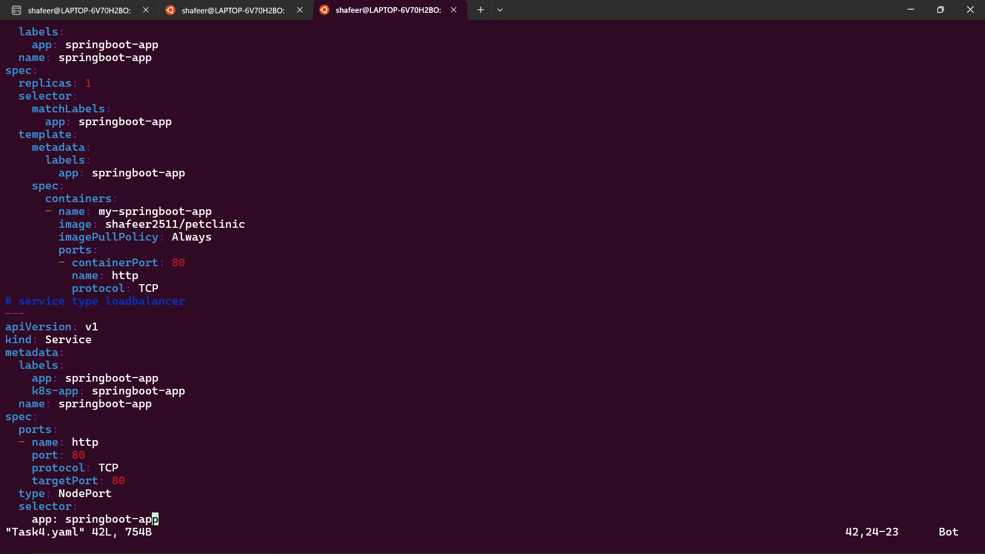

**Step 5: Apply**

Apply the changes made in the Task4.yaml file



**Step 6: Get Pods**

Get the pods information to check if it is running or not.

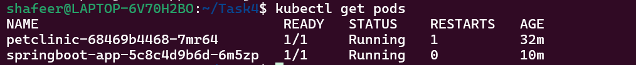

**Step 7: Service**

Open the service springboot-app in the browser

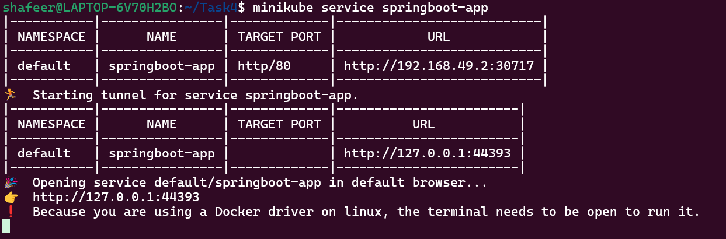

**Step 8: Output**

The output is shown in the browser in the localhost url present

